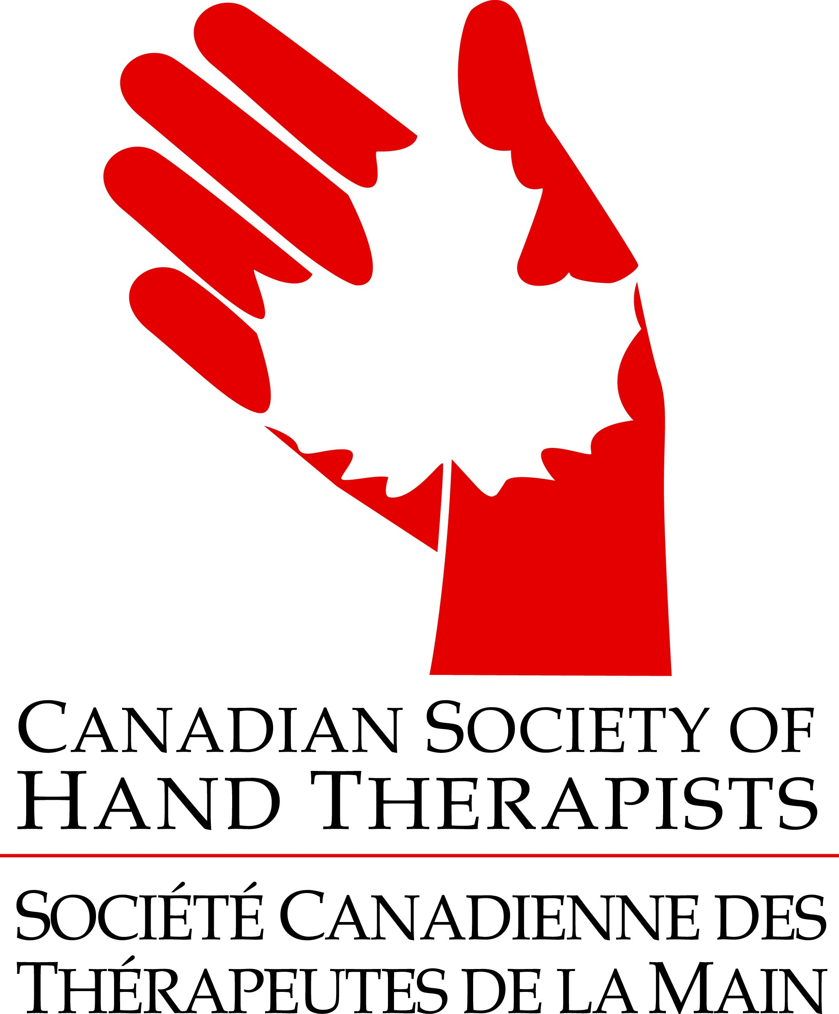

Call for Papers: CSHT Conference, April 27 - 28, 2018

The Canadian Society of Hand Therapists (CSHT) invites you to share your innovative clinical practice inquiries and/or the results of your research on hand and upper extremity topics at the 11th Annual meeting in our nation’s capital - Ottawa, Ontario. We welcome scientific or clinical abstract submissions, which are peer reviewed and may be accepted for an oral presentation or poster presentation. All accepted abstracts will be published in the CSHT newsletter – In Hand. Please note that CSHT allows abstracts previously submitted to other meetings. You may submit as many abstracts as you wish.

Scientific submissions include systematic reviews, scoping reviews, and original research in the quantitative or qualitative traditions.

Clinical submissions may include case studies, descriptions of new or newly adapted splint designs or other treatment strategies, or descriptions of clinical treatment programs.

Format of Abstract Submission
PLEASE ADHERE TO THE FOLLOWING FORMAT:
- Abstract submissions for a poster presentation should be a maximum of 250 words; no figures, tables or photographs
- Abstract submissions for a paper presentation should be a maximum of 500 words; no figures, tables or photographs
- All submissions must include the following information:
- Name of presenter (blinded for the review process)
- Name(s) of co-author(s) (blinded for the review process)
- E-mail address of primary author (blinded for the review process)
- Title of presentation
- Statement of Clinical OR Scientific submission
- Statement of preference for a Paper OR Poster format

The presenter of the poster or paper must be registered for the conference on the day of presentation. Student rates are available.

E-mail abstracts to:
Karen Landry
Scientific Chair, CSHT Conference 2018
landryk@dal.ca

Deadline for abstract submission: February 2, 2018
Notification of abstracts accepted: March 2, 2018

For more conference information, please visit www.csht.org. See you in Ottawa!!

